**AEM 6.3 features:**

Adobe has announced the official release of its new version Adobe Experience Manager 6.3 on 27-Apr-17 after the release of AEM 6.2 last year. It consists of all the Service pack and hotfixes of AEM 6.2 along with many more customer key fixes.

Top 10 features that are introduced in Adobe Experience Manager 6.3:-

Introduction to Production-ready components:- Faster time-to-market with Adobe-vetted, production-ready components based on best practices.

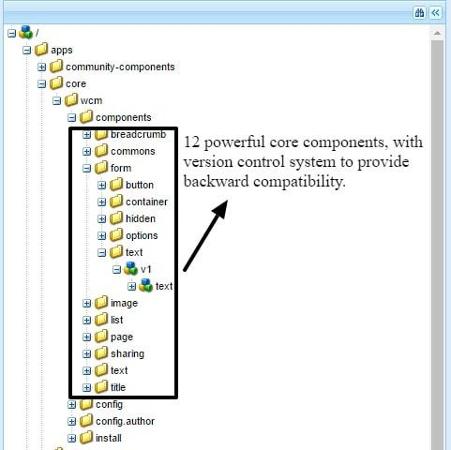

Experience fragments: Composition and delivery of experiences to both owned web properties and affiliated properties, like Pinterest and Facebook.  
  
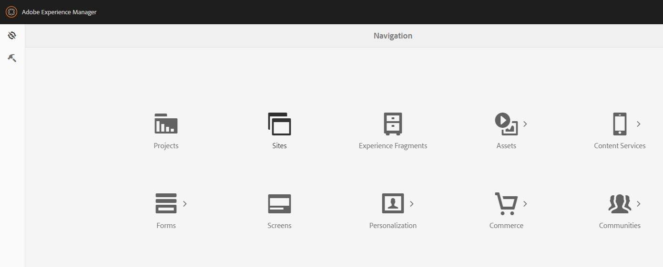

Stable online revision Clean up(online tar compaction):- From limited support to full support for online revision clean up. As customers are regularly forced to shut down their AEM production environments for maintenance which prevents them from publishing content during that time. (Up to 4 hours a week).  
  
Bulk workflow: Increased productivity with faster workflow-related tasks and ability to process multiple items in one click.

Performance and scale enhancements: Empower your teams to work more productively and efficiently with a broad range of enhancements to support large scale operations—including bulk ingestion, workflow processing, video processing and encoding, handling large files, repositories, and more.

Community ideation: New community engagement mode to source and surface the best ideas crowd-sourced from the community. Community can vote and rank to help prioritize and highlight the best content.

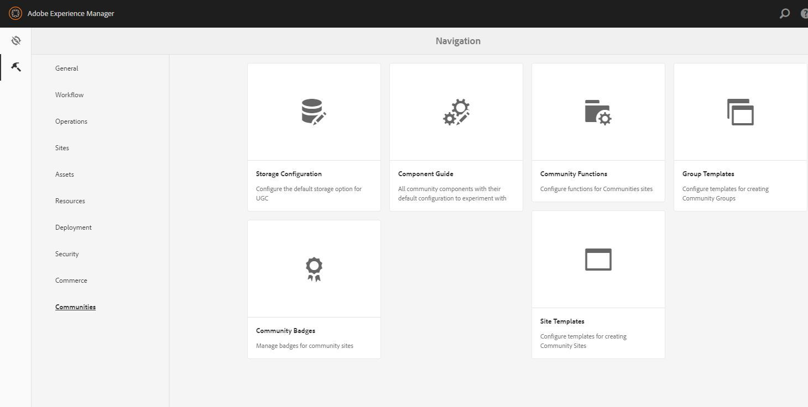  
  
Source user generated content: Livefyre is now fully integrated within Experience Manager, enabling marketers to rapidly discover, filter and manage user-generated content into the central repository of Experience Manager. Unlock the power of user-generated content from social sites such as Twitter, Facebook, Instagram and tell your brand’s most authentic and engaging story.

3D assets: Repurpose 3D assets to accelerate time to market and save on production costs. Upload, manage, view, and render 3D content created from Creative Cloud or many popular 3D applications. Easily rotate, zoom, change colors, textures, backgrounds (stages) and lighting on 3D objects to create a new set of images from an infinite number of camera angles to use in digital marketing campaigns.

Asset templates: Leverage self-service templates based on Adobe InDesign to create and export brochures, flyers and print ads that speeds time to market while complying with brand guidelines.

High-quality file format and color management: Experience Manager now uses Photoshop and Acrobat-quality image and PDF libraries to support high quality file operations such as conversion, previewing, raster and creating thumbnails and preserving color and embedded color profiles, using Adobe ICC profiles or your own. Deliver images with RGB, CMYK or grayscale so your digital assets look bright and beautiful across channels.

**Key Features for Upgrading to 6.3**

**1. Core stability and maturity of features**

With each iteration of AEM new features are added, existing features are enhanced and additional security hardening takes place. This is true from functional features of content management all the way down to the core foundation and repository. Features introduced in AEM are never static and evolve with every release to meet ever-changing customer needs. Upgrading to AEM 6.3 ensures the latest and greatest features. [Full release notes for AEM 6.3.](https://docs.adobe.com/docs/en/aem/6-3/release-notes.html)

**2. Online Revision Cleanup with new Oak Segment Tar format**

In previous version of Oak repository with TarMK maintenance required server downtime. In AEM 6.3 the new format for TarMK allows for [Online Revision Cleanup](https://docs.adobe.com/docs/en/aem/6-3/deploy/platform/revision-cleanup.html). This significantly simplifies operations and maintenance without down time.

**3. Asset Performance and Scalability**

Significant steps were taken in AEM 6.3 to improve both performance and scalability of Assets.

* Enhanced support for large asset repositories - 400TB repo size
* Enhanced support for large files - 20GB
* Performance improvements across ingestion (upload) - 15,000/day
* Browse, search and download - 20-30% increase over 6.2

**4. Latest Features of Adobe Experience Cloud**

Adobe Experience Cloud solutions like Adobe Analytics, Target, and Campaign continue to evolve and add powerful new features. Only AEM 6.3 will allow customers to leverage the latest and greatest offerings from Experience Cloud solutions.

**5. Classic UI to Touch UI migration**

It is recommended for customers currently using the Classic UI to upgrade to AEM 6.3 and then migrate to use the Touch UI. The Classic UI will be available in the next version of AEM but will be deprecated.

**6. End of Core Support for 5.6.x and 6.0**

5.6.x and 6.0 versions have reached the end of Core Support. Extended support for 5.6.x will end in less than a year (February 2018).

## Foundation Features

Below is a matrix of some key foundation features of AEM. Some of these features may have been introduced in versions earlier than 6.3 with enhancements added in each release.

|  |  |  |  |  |  |
| --- | --- | --- | --- | --- | --- |
| **Foundation Feature** | **5.6.x** | **6.0** | **6.1** | **6.2** | **6.3** |
| [**Oak Content Repository**](https://jackrabbit.apache.org/oak/docs/index.html) Provides far greater performance and scalability then predecessor Jackrabbit 2. |  | X | X | X | X |
| [**Custom Search Indexes**](https://docs.adobe.com/docs/en/aem/6-3/deploy/platform/queries-and-indexing.html) Ability to add custom index definitions to optimized query performance and search relevancy. |  | X | X | X | X |
| [**Online Revision Cleanup**](https://docs.adobe.com/docs/en/aem/6-3/deploy/platform/revision-cleanup.html) Perform repository maintenance without server downtime. |  |  |  |  | X |
| [**TarMK or MongoMK repository storage**](https://docs.adobe.com/docs/en/aem/6-3/deploy/platform/storage-elements-in-aem-6.html) Options to use simple, performant file-based storage of TarMK (next-generation version of TarPM) or scale horizontally with a MongoDB backed repository with MongoMK. |  | X | X | X | X |
| [**MongoMK performance and stability**](https://docs.adobe.com/docs/en/aem/6-3/deploy/platform/aem-with-mongodb.html)Continued enhancements have been made to MongoMK since it's introduction with AEM 6.0. |  |  | X | X | X |
| [**Amazon S3 DataStore**](https://docs.adobe.com/docs/en/aem/6-3/deploy/platform/data-store-config.html#Data Store Configurations) Leverage expandable cloud storage solution to store binary assets. | X | X+ | X | X | X |
| **Touch UI Feature Parity** Continued enhancements with authoring UI for speed with increased productivity and feature parity with Classic UI. |  |  |  | X | X |
| **OmniSearch** Quickly search and navigate AEM. |  |  |  | X | X |
| [**Operations Dashboard**](https://docs.adobe.com/docs/en/aem/6-3/administer/operations/operations-dashboard.html)Perform maintenance, monitor server health and analyze performance from within AEM. |  | X | X | X | X |
| [**HTL Template Language**](https://docs.adobe.com/docs/en/htl/overview.html)Modern templating engine that separates presentation from logic. Significantly reduces component development time. Incremental features added with each release. |  | X | X | X | X |
| [**Sling Models**](https://sling.apache.org/documentation/bundles/models.html)Flexible framework for modeling JCR resources into business objects and logic. Incremental features added with each release. |  | X | X | X | X |

## Security Features

Below is a matrix of some key security features offered by AEM. Some of these features may have been introduced in versions earlier than 6.3 with incremental enhancements added in each release.

|  |  |  |  |  |  |
| --- | --- | --- | --- | --- | --- |
| **Security Feature** | **5.6.x** | **6.0** | **6.1** | **6.2** | **6.3** |
| [**Introduction of Service Users**](https://docs.adobe.com/docs/en/aem/6-3/administer/security/service-users.html) Compartmentalizes permissions, avoids unnecessary use of Admin privileges. |  | X | X | X | X |
| [**Key Store Management**](https://docs.adobe.com/docs/en/aem/6-3/administer/security/saml-2-0-authenticationhandler.html#Add%20the%20Service%20Provider%20key%20and%20certificate%20chain%20to%20the%20AEM%20keystore) Global trust store, certificates, and keys all managed within the repository. |  | X | X | X | X |
| [**CSRF** **protection**](https://docs.adobe.com/docs/en/aem/6-3/develop/security/csrf-protection.html) Cross-Site Request Forgery protection out of the box. |  |  | X | X | X |
| [**CORS** **support**](https://helpx.adobe.com/experience-manager/kt/platform-repository/using/cors-security-article-understand.html) Cross-Origin Resource Sharing support for greater application flexibility. |  |  |  |  | X |
| [**Improved SAML authentication support**](https://docs.adobe.com/docs/en/aem/6-3/administer/security/saml-2-0-authenticationhandler.html)Improved SAML redirect, optimized group info, and key encryption issues resolved. |  |  | X | X | X |
| [**LDAP as an OSGi Configuration**](https://docs.adobe.com/docs/en/aem/6-3/administer/security/ldap-config.html)Simplifies management and updates of LDAP authentication. |  | X | X | X | X |
| [**OSGi Encryption support for plain-text passwords**](https://docs.adobe.com/docs/en/aem/6-3/release-notes/wcm-platform.html#Security)Passwords and other sensitive values can be saved in encrypted form and automatically decrypted. |  |  |  |  | X |
| [**CUG enhancements**](https://docs.adobe.com/docs/en/aem/6-3/administer/security/custom-user-groups.html#Upgrade%20to%20AEM%206.3)Closed-User Group implementation has been re-written to address performance and scalability issues. |  |  |  |  | X |
| [**SSL Wizard**](https://helpx.adobe.com/experience-manager/kt/platform-repository/using/ssl-wizard-technical-video-use.html) UI to simplify setup and management of SSL. |  |  |  |  | X |
| [**Encapsulated Token Support**](https://docs.adobe.com/docs/en/aem/6-3/administer/security/encapsulated-token.html) No longer necessary for "sticky" sessions to support horizontal authentication across publish instances. |  |  | X | X | X |

## Sites Features

Below is a matrix of some key Sites features offered by AEM. Some of these features may have been introduced in versions earlier than 6.3 with incremental enhancements added in each release.

**X+denotes that significant enhancements to the feature have been made.**

|  |  |  |  |  |  |
| --- | --- | --- | --- | --- | --- |
| **Sites Feature** | **5.6.x** | **6.0** | **6.1** | **6.2** | **6.3** |
| [**Touch Optimized Page Authoring**](https://helpx.adobe.com/experience-manager/kt/sites/using/page-editor-feature-video-use.html) Allows editors to leverage tablets and computers with touch screens. |  | X | X+ | X | X |
| [**Responsive Site Authoring**](https://docs.adobe.com/docs/en/aem/6-3/author/page-authoring/responsive-layout.html) Layouting mode allows editors to resize components based on device widths for responsive sites. |  |  | X | X | X+ |
| [**Editable Templates**](https://helpx.adobe.com/experience-manager/kt/sites/using/template-editor-feature-video-use.html) Allow specialized authors to create and edit page templates. |  |  |  | X | X+ |
| [**Core Components**](https://docs.adobe.com/docs/en/aem/6-3/author/page-authoring/default-components/core-components.html) Accelerate site development. Available on GitHub for frequent release schedule and flexibility. |  |  |  |  | X |
| [**Multi-Site Manager (MSM)**](https://docs.adobe.com/docs/en/aem/6-3/administer/sites/msm.html)Manage multiple web sites that share common content (i.e multi-lingual, multiple brands). | X | X | X | X+ | X |
| [**Content Translation Integrations**](https://docs.adobe.com/docs/en/aem/6-3/administer/sites/translation.html) Plug and play framework integrates with industry leading 3rd party translation services. |  |  | X | X+ | X |
| [**ContextHub**](https://docs.adobe.com/docs/en/aem/6-3/develop/personalization/contexthub.html)Next generation client context framework for personalization of content. |  | X | X+ | X | X |
| [**Launches**](https://docs.adobe.com/docs/en/aem/6-3/author/site-page-features/launches.html)Develop content for a future release without disrupting day-to-day authoring. | X | X | X | X+ | X |
| [**Content Fragments**](https://helpx.adobe.com/experience-manager/kt/sites/using/content-fragments-feature-video-understand.html) Create and curate editorial content de-coupled from presentation for easy reuse. |  |  |  | X | X+ |
| [**Experience Fragments**](https://helpx.adobe.com/experience-manager/kt/sites/using/experience-fragments-feature-video-use.html) Create reusable experiences and variations optimized for desktop, mobile, and social channels. |  |  |  |  | X |
| [**Adobe Analytics Integration and Content Insights**](https://docs.adobe.com/docs/en/ae) Easy integration of Adobe Analytics and DTM. Display performance info within Author environment. |  | X | X | X | X+ |
| [**Adobe Target Integration**](https://docs.adobe.com/docs/en/aem/6-3/author/personalization/content-targeting-touch.html) Step-by-step wizard to create targeted experiences, create reusable offer libraries. |  |  | X | X+ | X |
| [**Adobe Campaign Integration**](https://docs.adobe.com/docs/en/aem/6-3/administer/integration/marketing-cloud/campaign.html) Easy integration with next generation email campaign solution. |  | X | X | X | X |
| [**Screens**](https://docs.adobe.com/docs/en/aem/6-3/administer/screens.html) Manage experiences for digital signage and kiosks. |  |  |  | X | X |
| [**eCommerce**](https://docs.adobe.com/docs/en/aem/6-3/administer/ecommerce.html) Deliver branded, personalized shopping experiences across web, mobile, and social touchpoints | X | X | X | X | X |
| [**Communities**](https://docs.adobe.com/docs/en/aem/6-3/administer/communities/overview.html) Forums, threaded comments, event calendars, and many other features allow deep engagement with site visitors. | X | X | X+ | X | X |

## Assets Features

Below is a matrix of some key Assets features offered by AEM. Some of these features may have been introduced in versions earlier than 6.3 with incremental enhancements added in each release.

|  |  |  |  |  |  |
| --- | --- | --- | --- | --- | --- |
| **Assets Feature** | **5.6.x** | **6.0** | **6.1** | **6.2** | **6.3** |
| [**Touch Optimized UI**](https://docs.adobe.com/docs/en/aem/6-2/author/assets/managing-assets-touch-ui.html) Manage assets on desktop or with tablets and computers that support touch screens |  | X | X+ | X | X |
| [**Advanced Metadata Management**](https://docs.adobe.com/docs/en/aem/6-3/administer/content/assets/metadata.html)Metadata Templates, Metadata Schema Editor and Bulk Metadata Editing. |  | X | X | X+ | X |
| [**Task**](https://docs.adobe.com/docs/en/aem/6-3/author/projects/task-content.html)**and**[**Workflow**](https://docs.adobe.com/docs/en/aem/6-3/author/projects/working-with-workflows.html)**Management** Pre-built workflows and tasks for review and approval of digital assets leveraging AEM Projects. |  | X | X | X | X+ |
| **Scalability and Performance** Enhanced support for ingestion, upload and repository support up to 400tb |  |  |  |  | X |
| [**Link Share**](https://docs.adobe.com/docs/en/aem/6-3/administer/content/assets/link-sharing.html) Simple ad-hoc sharing of digital assets without a need to login. |  |  |  | X | X |
| [**Brand Portal**](https://docs.adobe.com/docs/en/aem/6-3/author/assets/brandportal.html) Cloud service SAAS solution for seamless sharing and distribution of digital assets. |  |  |  | X | X |
| [**Asset Insights**](https://docs.adobe.com/docs/en/aem/6-3/author/assets/managing-assets-touch-ui/asset-insights.html) Leverage Adobe Analytics to capture customer interaction of digital assets and view in AEM. |  |  |  | X | X+ |
| [**Multilingual Assets**](https://docs.adobe.com/docs/en/aem/6-3/author/assets/managing-assets-touch-ui/multilingual-assets.html) Translation support of asset metadata automatically with language roots. |  |  |  | X | X |
| [**Smart Tags and Moderation**](https://docs.adobe.com/docs/en/aem/6-3/author/assets/managing-assets-touch-ui/smart-tags.html) Leverage deep-learning technology to tag images automatically with useful metadata. |  |  |  |  | X |
| [**Integration with InDesign Server**](https://docs.adobe.com/docs/en/aem/6-3/administer/content/assets/indesign.html) Generate product catalogs. Create brochures, flyers and print ads based on InDesign templates. |  |  | X | X | X+ |
| [**Desktop App**](https://docs.adobe.com/docs/en/aem/6-3/administer/integration/aem-desktop-app.html) Sync assets to local desktop for editing with Creative Suite products. |  |  | X | X | X+ |
| **Adobe Imaging Librar**y Photoshop and Acrobat PDF libraries used for high quality file manipulation. |  |  |  |  | X |

### Dynamic Media Add-on to Assets

|  |  |  |  |  |  |
| --- | --- | --- | --- | --- | --- |
| **Dynamic Media Feature** | **5.6.x** | **6.0** | **6.1** | **6.2** | **6.3 + FP** |
| [**Imaging**](https://docs.adobe.com/docs/en/aem/6-3/author/assets/dynamic-media/managing-assets.html) Dynamically deliver images at different sizes and formats. |  | X | X | X | X+ |
| [**Video**](https://docs.adobe.com/docs/en/aem/6-3/administer/content/assets/processing-profiles/video-profiles.html) Advanced video encoding and adaptive video streaming |  | X | X | X | X+ |
| [**Interactive Media**](https://docs.adobe.com/docs/en/aem/6-3/author/assets/dynamic-media/interactive-images.html) Create interactive banners, videos with clickable content to showcase key offers. |  |  |  | X | X |
| **Sets (**[**Image**](https://docs.adobe.com/docs/en/aem/6-3/author/assets/dynamic-media/image-sets.html)**,**[**Spin**](https://docs.adobe.com/docs/en/aem/6-3/author/assets/dynamic-media/spin-sets.html)**,**[**Mixed Media**](https://docs.adobe.com/docs/en/aem/6-3/author/assets/dynamic-media/mixed-media-sets.html)**)** Allow users to zoom, pan, rotate and simulate a 360 degree viewing experience. |  | X | X | X | X+ |
| [**Viewers**](https://docs.adobe.com/docs/en/aem/6-3/administer/content/dynamic-media/viewer-presets.html) Custom branded rich media players and presets with support for different screens/devices. |  | X | X | X+ | X |
| [**Delivery**](https://docs.adobe.com/docs/en/aem/6-3/author/assets/dynamic-media/delivering-dynamic-media-assets.html) Flexible options for linking or embedding of Dynamic Media content and delivery over HTTP/2 protocol. |  | X | X | X+ | X+ |
| **Upgrade from Scene7 to Dynamic Media** Ability to migrate master assets and continue using existing S7 URLs. |  |  |  |  | X |

## Forms Features

Below is a matrix of some key Forms features offered by the AEM Forms Add-on. Some of these features may have been introduced in versions earlier than 6.3 with incremental enhancements added in each release.

|  |  |  |  |  |  |
| --- | --- | --- | --- | --- | --- |
| **Forms Feature** | **5.6.x** | **6.0** | **6.1** | **6.2** | **6.3** |
| [**Adaptive Forms Editor**](https://helpx.adobe.com/aem-forms/6-3/whats-new.html#Simplifiedauthoringexperience) Create engaging, responsive, and adaptive forms based on device and browser settings. |  | X | X+ | X+ | X+ |
| [**Document of Record**](https://helpx.adobe.com/aem-forms/6-3/generate-document-of-record-for-non-xfa-based-adaptive-forms.html)Create document to ensure long term storage of a data capture experience or print ready version. |  | X | X | X+ | X+ |
| [**Theme Editor**](https://helpx.adobe.com/aem-forms/6-3/themes.html) Create reusable themes to style components and panels of a form. |  |  |  | X | X |
| [**Template Editor**](https://helpx.adobe.com/aem-forms/6-3/template-editor.html) Standardize and implement best practices for adaptive forms. |  |  |  | X | X |
| [**Adobe Sign Integration**](https://helpx.adobe.com/aem-forms/6-3/whats-new.html#EnhancedintegrationwithAdobeSign) Allow deployment of Adobe Sign integrated forms based signing scenarios. |  |  |  | X | X+ |
| [**Correspondence Management**](https://helpx.adobe.com/aem-forms/6-3/whats-new.html#EnhancedCorrespondenceManagement) With AEM Forms, you can create, manage, and deliver personalized and interactive customer correspondences. |  | X | X | X | X+ |
| [**Third-Party Data Integration**](https://helpx.adobe.com/aem-forms/6-3/whats-new.html#AEMFormsdataintegration) Using Data Integration, data is fetched from disparate data sources based on user inputs in a form. On form submission, the captured data is written back to the data sources. |  |  |  |  | X |
| [**Workflow (on OSGi) for Forms Processing**](https://helpx.adobe.com/aem-forms/6-3/whats-new.html#FormscentricAEMWorkflowsforAEMFormsonOSGi)Simplified deployment for forms approval processes. |  |  |  |  | X |
| [**Integration with Marketing Cloud**](https://helpx.adobe.com/aem-forms/6-3/measure-improve-performance-forms-documents.html) Integration with Adobe Analytics and Adobe Target to enhance and measure customer experiences. |  |  | X | X | X |
| [**Form Manager**](https://helpx.adobe.com/aem-forms/6-3/whats-new.html#Enhancedformsmanagement)Single location to manage all form/document/correspondence such as enabling analytics, translation, A/B testing, reviews, and publishing. |  | X | X | X | X+ |
| [**AEM Forms App**](https://helpx.adobe.com/aem-forms/6-3/whats-new.html#EnhancedAEMFormsApp)Allow for online/offline forms processing within an app on iOS, Android, or Windows. |  | X | X | X+ | X+ |
| **Adaptive Documents** Create rich documents such as targeted statements with interactive elements such as charts. |  |  | X | X | X+ |
| [**Workflow (J2EE) for Forms Processing**](https://helpx.adobe.com/pdf/aem-forms/6-3/WorkbenchHelp.pdf)Build complex forms/document centric workflows utilizing an intuitive IDE. |  | X | X | X | X |
| [**AEM Forms Document Security**](https://helpx.adobe.com/aem-forms/6-3/whats-new.html#EnhancedDocumentSecurity)Secure access and authorization of PDF and Office documents. |  | X | X | X+ | X+ |
| [**Testing Frameworks**](https://helpx.adobe.com/aem-forms/6-3/whats-new.html#Simplifiedauthoringexperience)Use the Calvin framework and Chrome plugin to support and debug adaptive forms. |  |  |  |  | X |

t last month’s Adobe Summit, [Adobe](http://www.perficient.com/partners/adobe) officially unveiled and introduced the next generation of Adobe Experience Manager, AEM 6.3. There are a lot new and exciting things that the community is looking forward to in this new version. And this year, I am thrilled to have the opportunity to join the Adobe AEM Beta Program to preview and test the application. In case you missed Summit or aren’t involved with the Beta Program, I’ve summarized all the new and enhanced features that you need to know (and likely care about) in Adobe Experience Manager (AEM) 6.3, which will become available to the general public next week, on Wednesday, April 26.

#### **Projects, workflows and inbox (and collaboration)**

* **NEW**Master Project – Project team roles and permissions can be assigned to the master project and reused across multiple projects.
* **NEW** Calendar View – Projects and tasks shown in a calendar view for better project management and scheduling.

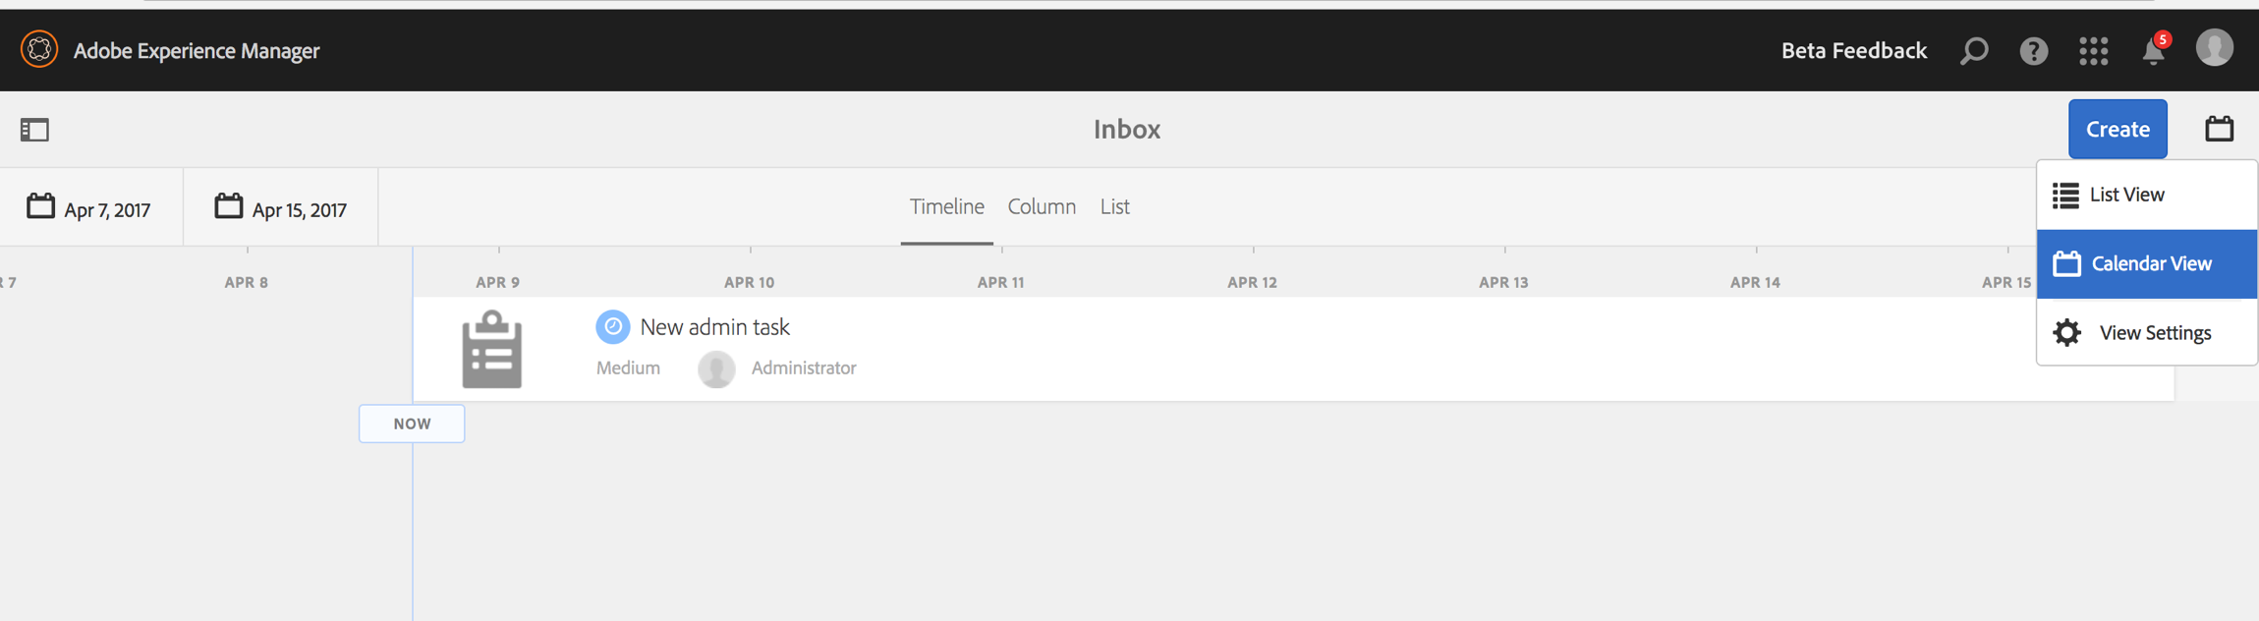

* **Enhanced**inbox user interface for greater collaboration and visibility into user’s tasks and workflow.

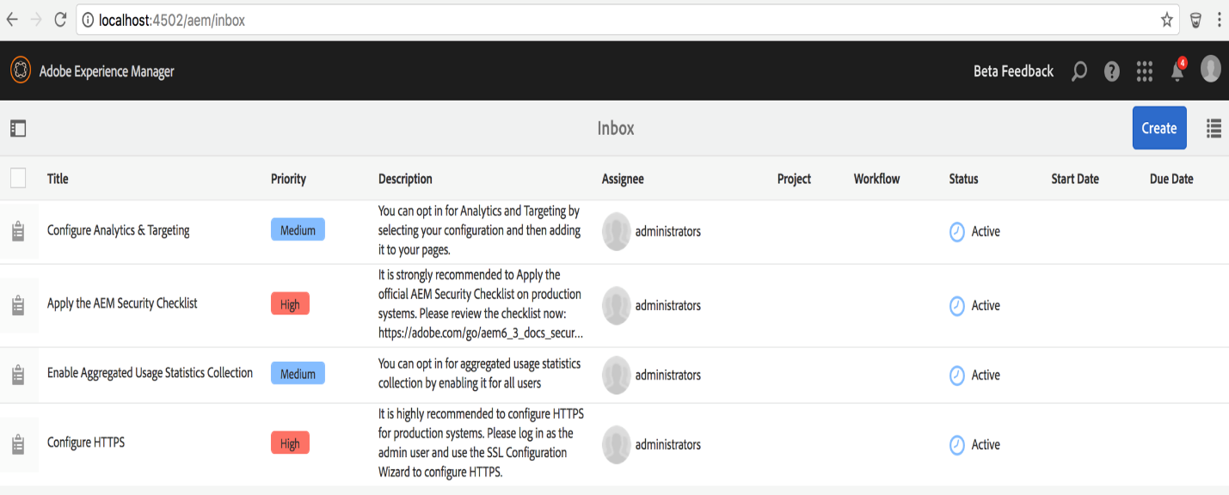

#### **Sites**

* **NEW** Experience Fragments – A set of content that can be reused across channels (owned channels and third-party touch points).
* **Enhanced**Content Fragments – Enhancements include import plain text file, insert asset, summarize text with target number, rename/delete content fragment variations, add fragment to collection, asset card display, download content fragment, enhance the use of assets in content fragment.

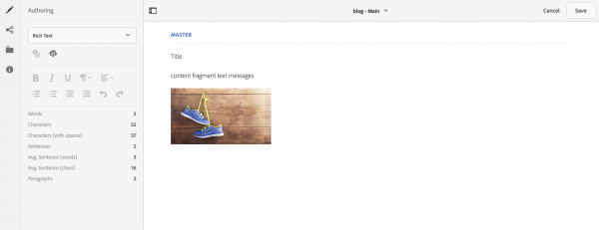

* **Enhanced** Touch UI – Sites editor, NEW Live Copy Overview, Blueprint Configuration Manager, Timewarp.
* **Enhanced** Sites Template Editor – Consistent author experience with Sites, advanced policy configurations made available with Editable Templates.

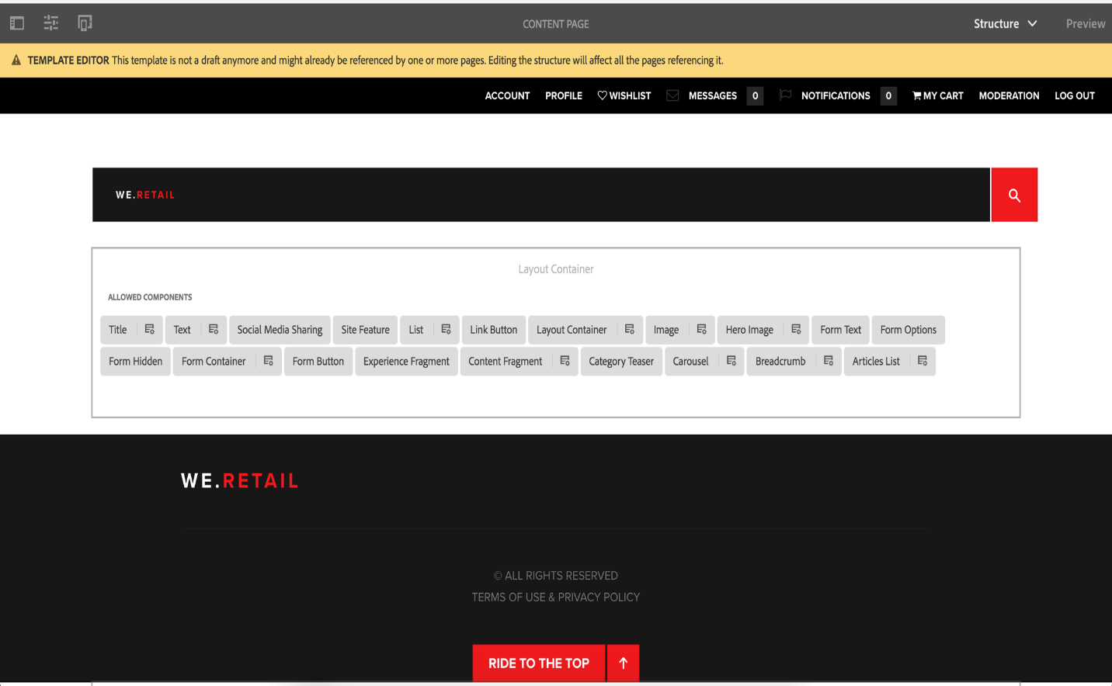

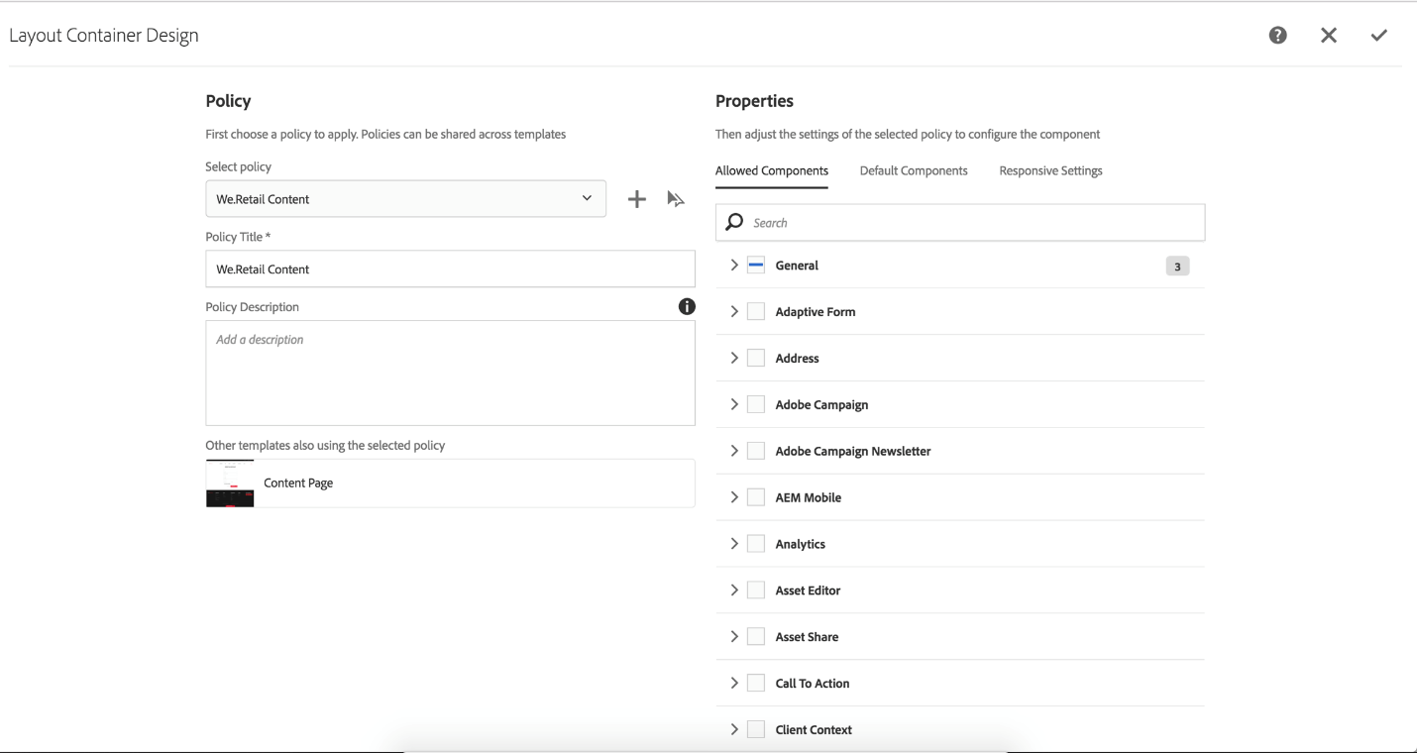

* Manage Publication from AEM Sites – Console for management of bulk un/publication.
* **NEW** AEM Sites Activity Map integration – Display Adobe Analytics data directly on the AEM Sites page with different settings.

#### https://blogs.perficient.com/adobe/files/2017/04/Screen-Shot-2017-04-15-at-10.27.09-AM.png **Assets**

* **Enhanced** Assets Search – New Search Boost to add keywords to the asset, multi-value search predicate, tag predicate.
* **New** side-by-side comparison of images in Assets’ Review Task.
* **NEW** Check-in/Check-out – Let a user make changes to an asset while preventing other users from modifying the asset.
* **Enhanced** AEM Desktop App – Sync Status console.
* Smart Tags and Manage Tags console are available.

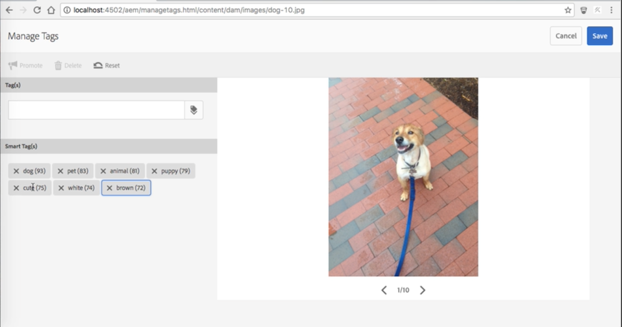

* **New** create interactive videos – Allows user to create segments for the video asset and associate call-to-actions.
* **Enhanced** Asset Annotation – Use different colors, print, generate PDF output.
* **New** AEM Asset Template – Allows marketers to create brochures or other marketing materials easier when integrated with InDesign server.
* Dynamic Media features available:- Color management, custom video thumbnails, non flash video player (using HLS technology, Apple’s HTTP Live Streaming video delivery protocol), Dynamic Media Viewer enhancements.

#### **Forms**

* **New**User Profile Integration – Automatically pre-fill adaptive form with user data.
* Integrate with JDBC database and create form data model.
* **Enhanced** Adobe Sign integration – Support anonymous and multi-user sign use-cases.
* **Enhanced** Correspondence Management capabilities.

#### **Platform**

**New** Online Revision Clean Up – An addition to offline revision clean up with minimal impact to AEM performance, allowing you to keep a clean performant AEM instance.

#### **Communities**

* **NEW**Featured Content – Allow community members to highlight content for blogs, forums, etc.
* **NEW**Ideation Feature – Allow community members to create, view, follow, vote for ideas.
* Prevent Spam and Flooding – Using contribution limits feature.
* **Enhanced** Badge Management.
* **NEW**Database Storage Resource Provider (DSRP) – Use a relational database to store user generated content (UGC).
* Dispatcher Caching for Guest Visitors – Allow dispatcher to serve fully cached versions of a community site’s pages.
* Edit Community Groups from Author.
* Use [Livefyre](http://www.adobe.com/marketing-cloud/enterprise-content-management/ugc-content-platform.html" \t "_blank) components to embed UGC in experience.

#### **Mobile**

* **NEW** AEM Mobile Content Services – Easier to request content that’s managed by AEM, without deep knowledge of AEM’s content repository (JCR) and web framework (Sling).
* Model Management – Create and manage models, which describes the type of content and denotes what information will be available to the native application, entities, and spaces.

There truly are a lot of new and enhanced features that will come with Adobe Experience Manager (AEM) 6.3. With Internet of Things (IoT) devices become more and more popular, enterprises are looking to streamline digital experience across more than smartphones, tablets and desktops. CMS will need to not only support more types of content, but also deliver a fluid experience across different channels and devices easily. I am happy to see AEM 6.3 continues to empower the creation and management of digital experiences, backed by cutting-edge technology. AEM’s user-friendly interface also gives you access to data insights and business intelligence – ultimately providing an integrative system for markers to manage content.

**SlingRepository.loginAdministrative methods have been defined to provide access to the resource tree and JCR Repository**.

Consequently the following methods are being deprecated

* **ResourceResolverFactory.getAdministrativeResourceResolver**
* **ResourceProviderFactory.getAdministrativeResourceProvider**
* **SlingRepository.loginAdministrative**

and alternatively we started using service authentication method **getServiceResourceResolver**to get the resourceResolver and then making a systme user and mapping service with user in felix congigurations.

like this <service-name>[:<subservice-name>]=<authorizable id of a JCR system user>]

### **Replicating from Publish to Author**

Some features allow users to enter data on a publish instance.

In some cases, a type of replication known as reverse replication, is needed to return this data to the author environment from where it is redistributed to other publish environments.  Due to security considerations, any traffic from the publish to the author environment must be strictly controlled.

Reverse replication uses an agent in the publish environment which references the author environment. This agent places the data into an outbox. This outbox is matched with replication listeners in the author environment. The listeners poll the outboxes to collect any data entered and then distribute it as necessary. This ensures that the author environment controls all traffic.

In other cases, such as for Communities features (for example, forums, blogs, comments, and reviews), the amount of user generated content (UGC) being entered in the publish environment is difficult to efficiently synchronize across AEM instances using replicaiton.

AEM [Communities](https://docs.adobe.com/docs/en/aem/6-3/administer/communities/overview.html) never uses replication for UGC.  Instead, the deployment for Communities requires a common store for UGC (see [Community Content Storage](https://docs.adobe.com/docs/en/aem/6-3/administer/communities/srp.html)).

### **Replication - Out of the Box**

The Geometrixx website that is included in a standard installation of AEM can be used to illustrate replication.

To follow this example and use the default replication agents you need to Install AEM with:

* the author environment on port 4502
* the publish environment on port 4503

NOTE

Enabled by default :

* Agents on author : Default Agent (publish)

Effectively disabled by default (as of AEM 6.1) :

* Agents on author  : Reverse Replication Agent (publish\_reverse)
* Agents on publish : Reverse Replication (outbox)

To check the status of either the agent or the queue use the **Tools** console.  
See [Monitoring your Replication Agents](https://docs.adobe.com/docs/en/aem/6-3/deploy/configuring/replication.html#Monitoring your Replication Agents).

#### **Replication (Author to Publish)**

1. Navigate to the support page on the author environment.  
       http://localhost:4502/content/geometrixx/en/support.html
2. Edit the page to add some new text.
3. **Activate Page** to publish the changes.
4. Open the support page on the publish environment:  
       http://localhost:4503/content/geometrixx/en/support.html
5. You can now see the changes that you entered on author.

This replication is actioned from the author environment by the:

* **Default Agent (publish)**   
  This agent replicates content to the default publish instance.  
  Details of this (configuration and logs) can be accessed from the Tools console of the author environment; or:  
  <http://localhost:4502/etc/replication/agents.author/publish.html>.

## Configuring your Replication Agents

For information about connecting replication agents to the publish instance using MSSL, see [Replicating Using Mutual SSL](https://docs.adobe.com/docs/en/aem/6-3/deploy/configuring/replication/mssl-replication.html).

### **Configuring your Replication Agents from the Author Environment**

From the Tools tab in the author environment you can configure replication agents that reside in either the author environment (**Agents on author**) or the publish environment (**Agents on publish**). The following procedures illustrate the configuration of an agent for the author environment, but can be used for both.

NOTE

When a dispatcher handles HTTP requests for author or publish instances, the HTTP request from the replication agent must include the PATH header. In addition to the following procedure, you must add the PATH header to the dispatcher list of client headers. (See [/clientheaders (Client Headers)](https://docs.adobe.com/docs/en/dispatcher.html#par_114_12_0005).)

1. Access the **Tools** tab in AEM.
2. Click **Replication** (left pane to open the folder).
3. Double-click **Agents on author** (either the left or the right pane).
4. Click the appropriate agent name (which is a link) to show detailed information on that agent.
5. Click **Edit** to open the configuration dialog:

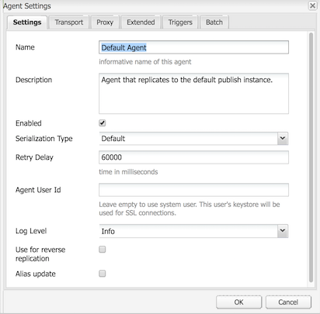

1. The values provided should be sufficient for a default installation. If you make changes then click **OK** to save them (see [Replication Agents - Configuration Parameters](https://docs.adobe.com/docs/en/aem/6-3/deploy/configuring/replication.html#Replication Agents - Configuration Parameters) for more details of the individual parameters).

### **Configuring Reverse Replication**

Reverse replication is used to get user content generated on a publish instance back to an author instance. This is commonly used for features such as surveys and registration forms.

For security reasons, most network topologies do not allow connections *from* the "Demilitarized Zone" (a subnetwork that exposes the external services to an untrusted network such as the Internet).

As the publish environment is usually in the DMZ, to get content back to the author environment the connection must be initiated from the author instance. This is done with:

* an *outbox* in the publish environment where the content is placed.
* an agent (publish) in the author environment which periodically polls the outbox for new content.

NOTE

For AEM [Communities](https://docs.adobe.com/docs/en/aem/6-3/administer/communities/overview.html), replication is not used for user generated content on a publish instance.  See [Community Content Storage](https://docs.adobe.com/docs/en/aem/6-3/administer/communities/srp.html).

To do this you need:

**A reverse replication agent in the author environment**

This acts as the active component to collect information from the outbox in the publish environment:

If you want to use reverse replication then ensure that this agent is activated.

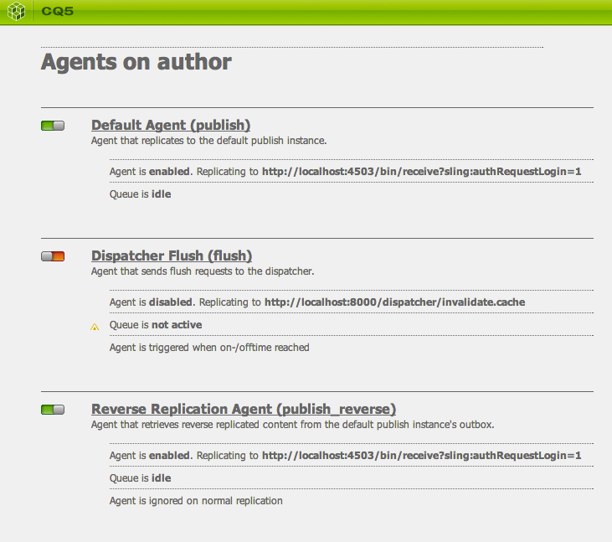

**A reverse replication agent in the publish environment (an outbox)**

This is the passive element as it acts as an "outbox". User input is placed here, from where it is collected by the agent in the author environment.

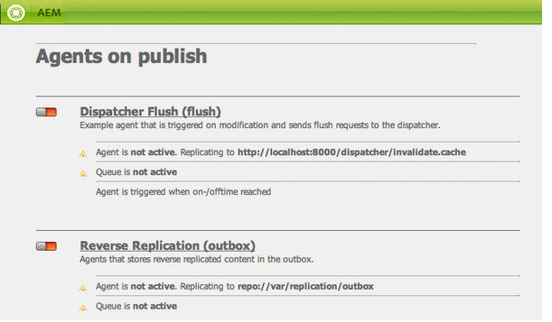

### **Configuring Replication for Multiple Publish Instances**

NOTE

Only content is replicated - user data is not (users, user groups, and user profiles).

To synchronize user data across multiple publish instances, enable [User Synchronization](https://docs.adobe.com/docs/en/aem/6-3/administer/security/security/sync.html).

Upon installation a default agent is already configured for replication of content to a publish instance running on port 4503 of the localhost.

To configure replication of content for an additional publish instance you need to create, and configure, a new replication agent:

1. Open the **Tools** tab in AEM.
2. Select **Replication**, then **Agents on author** in the left panel.
3. Select **New...**.
4. Set the **Title** and **Name**, then select **Replication Agent**.
5. Click **Create** to create the new agent.
6. Double-click the new agent item to open the configuration panel.
7. Click **Edit** - the **Agent Settings** dialog will open - the **Serialization Type** is already defined as Default, this must remain so.
   * In the **Settings** tab:
     + Activate **Enabled**.
     + Enter a **Description**.
     + Set the **Retry Delay** to 60000.
     + Leave the **Serialization Type** as Default.
   * In the **Transport** tab:
     + Enter the required URI for the new publish instance; for example,  
           http://localhost:4504/bin/receive.
     + Enter the site-specific user account used for replication.
     + You can configure other parameters as required.
8. Click **OK** to save the settings.

You can then test operation by updating, then publishing, a page in the author environment.

The updates will appear on all publish instances that have been configured as above.

If you encounter any problems, you can check the logs on the author instance. Depending on the level of detail required you can also set the **Log Level** to Debug using the **Agent Settings** dialog as above.

NOTE

This can be combined with use of the [Agent User Id](https://docs.adobe.com/docs/en/aem/6-3/deploy/configuring/replication.html#Agent User Id) to select different content for replicating to the individual publish environments. For each publish environment:

1. Configure a replication agent for replicating to that publish environment.
2. Configure a user account; with the access rights required to read the content that will be replicated to that specific publish environment.
3. Assign the user account as the **Agent User Id** for the replication agent.

### **Configuring a Dispatcher Flush agent**

Default agents are included with the installation. However, certain configuration is still needed and the same applies if you are defining a new agent:

1. Open the **Tools** tab in AEM.
2. Click **Deployment**.
3. Select **Replication**and then **Agents on publish**.
4. Double-click on the **Dispatcher Flush** item to open the overview.
5. Click **Edit** - the **Agent Settings** dialog will open:
   * In the **Settings** tab:
     + Activate **Enabled**.
     + Enter a **Description**.
     + Leave the **Serialization Type** as Dispatcher Flush, or set it as such if creating a new agent.
     + (optional) Select **Alias update** to enable alias or vanity path invalidation requests to Dispatcher.
   * In the **Transport** tab:
     + Enter the required URI for the new publish instance; for example,  
           http://localhost:80/dispatcher/invalidate.cache.
     + Enter the site-specific user account used for replication.
     + You can configure other parameters as required.

For Dispatcher Flush agents, the URI property is used only if you use path-based virtualhost entries to differentiate between farms, you use this field to target the  farm to invalidate. For example, farm #1 has a virtual host of www.mysite.com/path1/\* and farm #2 has a virtual host of www.mysite.com/path2/\*. You can use a URL of /path1/invalidate.cache to target the first farm and /path2/invalidate.cache to target the second farm.

NOTE

If you have installed AEM in a context other than the recommended default context, then you need to configure the [HTTP Headers](https://docs.adobe.com/docs/en/aem/6-3/deploy/configuring/replication.html#Extended) in the **Extended** tab.

1. Click **OK** to save the changes.
2. Return to the **Tools** tab, from here you can **Activate** the **Dispatcher Flush** agent (**Agents on publish**).

The **Dispatcher Flush** replication agent is not active on author. You can access the same page in the publish environment by using the equivalent URI; for example, http://localhost:4503/etc/replication/agents.publish/flush.html.

AEM Interview Questions:

1). AEM 6.3 features

2). Explain AEM architecture

3). Parameters passed to execute() method of Workflow process.

4). How to get the page path with workitem parameter passed to execute() method of Workflow process.

5). Advantages of touch UI over Classic UI dialog

6). Explain different OSGI annotations

5). Different attributes of @Component annotation and explain their usage

7). Explain Sling resolution (Ex URL which they gave: <http://www.hcl.com?text=dcdsfd/sdfg>)

8). Have you done the load balancing in your project

9). Dispatcher concept, replication concept

10). Reverse replication concept

11). How to include header and footer in all the pages. Y cant u go with design\_dialog than iparsys.

12). Different ways of registering Sling Servlet

13). How to call a third party service in sling servlet.

14). How to call a osgi service through JS

15). Different annotations of sling model class

16). Scaffolding

Custom Loggers

* Create folder in apps

-Name : config type should be nt:folder

* Create node inside config folder

-Name: **org.apache.sling.commons.log.LogManager.factory.config-<identifier>**

**-** Type: Sling:OsgiConfig

Example**:** **org.apache.sling.commons.log.LogManager.factory.config-Logger**

replace the **<identifier>** give unique name.

**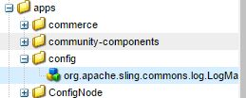**

**Add Properties to the Sling:OsgiConfig node:**

**Log File:**

Name: org.apache.sling.commons.log.file

Type: String

Value: Training/custom.log

**Package:**

Name: org.apache.sling.commons.log.names

Type: String[]

Value: com.test,com.training

**Lavel:**

Name: org.apache.sling.commons.log.level

Type: String

Value: info, debug…etc

**Pattern:**

Name: org.apache.sling.commons.log.pattern

Type: String

Value: {0,date,dd.MM.yyyy HH:mm:ss.SSS} \*{4}\* [{2}] {3} {5}

{0} The timestamp of type java.util.Date  
{1} the log marker  
{2} the name of the current thread  
{3} the name of the logger  
{4} the log level  
{5} the log message

**Number of files:**

Name: org.apache.sling.commons.log.file.number

Type: Long

Value: 5

**Size:**

Name: org.apache.sling.commons.log.file.size

Type: String

Value: '.'yyyy-MM

|  |  |
| --- | --- |
| '.'yyyy-MM | Rotation at the beginning of each month |
| '.'yyyy-ww | Rotation at the first day of each week (depends on the locale). |
| '.'yyyy-MM-dd | Rotation at midnight each day. |
| '.'yyyy-MM-dd-a | Rotation at midnight and midday of each day. |
| '.'yyyy-MM-dd-HH | Rotation at the top of every hour. |
| '.'yyyy-MM-dd-HH-mm | Rotation at the beginning of every minute. |

**Config Nodes & Dynamic Configuration**

Create folder in apps type nt:folder

-Ex: configNode

-create two more nt:folders inside configNode

Ex: config.author

config.publish

-Create node under the above two folder type : sling:OsgiConfig name shoud be same

Ex-local

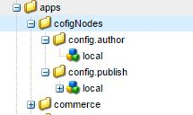

Add properties to the node with the same Name and different value

* Ex:Name: demo.url

Type: String

Value: <http://localhost:4504>

Name: demo.url

Type: String

Value: <http://localhost:45047>

**Run Mode:**

cq5-runmode-<*port-number*>

* config, applicable for all run modes
* config.author, used in author run mode
* config.publish, used in publish run mode
* config.<*run-mode*>, used in the applicable run mode

Create Osgi service get the value depends on the Run Mode.

Interface:

**public** **interface** ConfigurationUtil {

**public** String getConfig(String pid, String key);

}

Class:

@Component

@Service

**public** **class** ConfigurationUtilImpl **implements** ConfigurationUtil {

**private** Logger LOG = LoggerFactory.*getLogger*(ConfigurationUtilImpl.**class**);

@Reference(cardinality = ReferenceCardinality.*MANDATORY\_UNARY*, policy = ReferencePolicy.*STATIC*)

**private** ConfigurationAdmin configAdmin;

**private** Configuration conf = **null**;

**public** String getConfig(String pid, String key) {

LOG.info("Test inside method");

**try** {

**if** (configAdmin != **null**) {

conf = configAdmin.getConfiguration(pid);

**if** (conf != **null**) {

**if** (**null** != conf.getProperties() && **null** != conf.getProperties().get(key)) {

String a = (String) conf.getProperties().get(key);

**return** a;

}

}

} **else** {

LOG.error("Configuration for pid " + pid + " is Null");

}

} **catch** (Exception exception) {

exception.printStackTrace();

}

**return** **null**;

}

}

Calling Service

<%

ConfigurationUtil confUtil = sling.getService(ConfigurationUtil.class);

String val = confUtil.getConfig("local" , "demo.url");

out.print("Value-------: "+val);

%>

Note:

* if ur running instance should author it will get the value Value: <http://localhost:4504>
* if ur running instance should publish it will get the value Value: <http://localhost:4507>

Depends on run mode it will fitch the values.